Sermon Notes
Follow the Leader
Pastor Ron Wood
February 28, 2021
Mark 8:34-35

Follow the Leader
Mark 8:34-35 ³⁴ Then he called the crowd to him along with his disciples and said: “Whoever wants to be my disciple must deny themselves and take up their cross and follow me. ³⁵ For whoever wants to save their life will lose it, but whoever loses their life for me and for the gospel will save it.”

There is a Desired Outcome
in the Life of a Follower of Jesus.

Why Follow Jesus?
Simply this: To Save Your Life.
- From Brokenness.
- From Meaningless.

So How do we do this?
Deny our Selves, Take up our Cross, and Follow Jesus!
Lose our lives for Jesus and the Gospel.

There is an end: Being.
Point is not, “What do we do?”
It is, “Who are we becoming?”

Who are Those Who Follow Jesus?
1. They Bear “The Fruit of the Spirit”. Gal. 5:22-23
2. They Act Like Sheep. John 10:27-28
Sheep Listen.
Sheep are known by God.
Sheep Follow.
Sheep are Safe with the Shepherd.

Sheep are ok as long as they listen to the right Shepherd.
John 10:10
First Advent: The Lamb of God.
Second Coming: The Lion of Judah!

3. They Love Like Jesus.

John 13:34
Ephesians 5:1
Colossians 3:12-14
1 John 4:10

What are the Means to reach that end? 2 Pet. 1:3-10

2 Means of Living as Follower of Jesus:

1. Followers Commit to Follow.
They Believe and Receive Jesus.
John 1:12

2. Followers Commit to Transformation Through Training.
2 Cor 5:17
Luke 6:40
1 Tim. 4:7

What does that Training Look like?

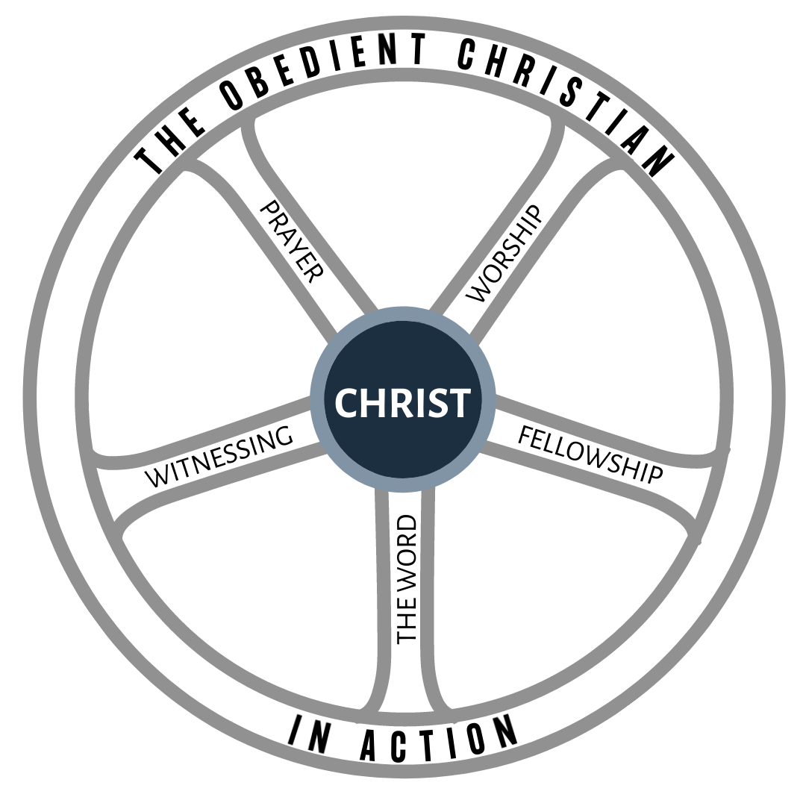

Transformation comes from Training, not Wishing!

Sermon Notes
Follow the Leader
Pastor Ron Wood
February 28, 2021
Mark 8:34-35

Follow the Leader
Mark 8:34-35 ³⁴ Then he called the crowd to him along with his disciples and said: “Whoever wants to be my disciple must deny themselves and take up their cross and follow me. ³⁵ For whoever wants to save their life will lose it, but whoever loses their life for me and for the gospel will save it.”

There is a Desired _________________
in the Life of a Follower of Jesus.

Why Follow Jesus?
Simply this: To __________ Your ________________.
- From B___________________.
- From M___________________.

So How do we do this?
Deny our Selves, Take up our Cross, and Follow Jesus!
____________ our lives for Jesus and the Gospel.

There is an end: Being.
Point is not, “What do we ____________?”
It is, “____________ are we becoming?”

Who are Those Who Follow Jesus?
1. They ______ “The Fruit of the Spirit”. Gal. 5:22-23
2. They Act Like _______________. John 10:27-28
Sheep __________________.
Sheep are _______________ by God.
Sheep _________________.
Sheep are _______________ with the Shepherd.

Sheep are ok as long as they listen to the right Shepherd.
John 10:10
Sermon Notes
Follow the Leader
Pastor Ron Wood
February 28, 2021
Mark 8:34-35

Follow the Leader
Mark 8:34-35 ³⁴ Then he called the crowd to him along with his disciples and said: “Whoever wants to be my disciple must deny themselves and take up their cross and follow me. ³⁵ For whoever wants to save their life will lose it, but whoever loses their life for me and for the gospel will save it.”

There is a Desired _________________
in the Life of a Follower of Jesus.

Why Follow Jesus?
Simply this: To __________ Your ________________.
- From B___________________.
- From M___________________.

So How do we do this?
Deny our Selves, Take up our Cross, and Follow Jesus!
____________ our lives for Jesus and the Gospel.

There is an end: Being.
Point is not, “What do we ____________?”
It is, “____________ are we becoming?”

Who are Those Who Follow Jesus?
1. They ______ “The Fruit of the Spirit”. Gal. 5:22-23
2. They Act Like _______________. John 10:27-28
Sheep __________________.
Sheep are _______________ by God.
Sheep _________________.
Sheep are _______________ with the Shepherd.

Sheep are ok as long as they listen to the right Shepherd.
John 10:10
First Advent: The L__________ of God.
Second Coming: The L__________ of Judah!

3. They _____________ Like Jesus.

John 13:34
Ephesians 5:1
Colossians 3:12-14
1 John 4:10

What are the M_______ to reach that end? 2 Pet.1:3-10

2 Means of Living as Follower of Jesus:

1. Followers Commit to __________________.
They B____________ and R___________ Jesus.
John 1:12

2. Followers Commit to T__________ Through T_______.
2 Cor 5:17
Luke 6:40
1 Tim. 4:7

What does that Training Look like?

Transformation comes from
T___________________, not W_______________!

First Advent: The L__________ of God.
Second Coming: The L__________ of Judah!

3. They _____________ Like Jesus.

John 13:34
Ephesians 5:1
Colossians 3:12-14
1 John 4:10

What are the M_______ to reach that end? 2 Pet.1:3-10

2 Means of Living as Follower of Jesus:

1. Followers Commit to __________________.
They B____________ and R___________ Jesus.
John 1:12

2. Followers Commit to T__________ Through T_______.
2 Cor 5:17
Luke 6:40
1 Tim. 4:7

What does that Training Look like?

Transformation comes from
T___________________, not W_______________!

