Sermon Notes
Breaking The Cycle
Pastor PJ Jimenez
December 29, 2019
2 Kings 22

Who was King Josiah?
- Son of ________ and grandson of ________ (2 Kings 21:20)
- Known to be _______ (“didn’t turn left or right” v.2)
- From the line of ____________.
- Story is also written in 2 _______________.

What is an idol?
Something that takes away the________of worship from God

John 21:23-24
^{“23} Yet a time is coming and has now come when the true worshipers will worship the Father in the Spirit and in truth, for they are the kind of worshipers the Father seeks. ²⁴ God is spirit, and his worshipers must worship in the Spirit and in truth.” (NIV)

Why we create idols
- Provides ________
- _________ sense of security

Application
- FIt your _______ into God’s plan, not ______ into your life plan.
- The circumstances we ______ ______ in does not have to _______ who are are today.
- We must be________ in what circumstances or children are being raised in.
- __________ your cycle
- What are your idols?

Israel’s Cycle of Sin
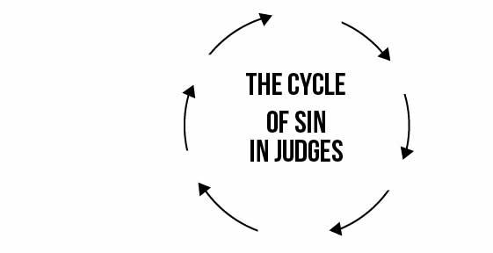

What are your top priorities in life?
1.

2.

3.

How can you break the cycles in your life? What changes can you make to match your life priorities with your life’s reality?

